CN Lab Report – Week 6

PES1201800366

Aditeya Baral

**1. Task 1**

**1.1 Configuring Topology**

* The network devices are organised in the required topology shown.
* IP Addresses have been assigned to each interface being used on the routers and end systems.
* The routing tables are then configured manually by adding the required routing information
* A PDU packet is then transferred from one end system on a network to another on a different network.
* If the packet transfer is successful, a successful status is shown in the bottom right corner.

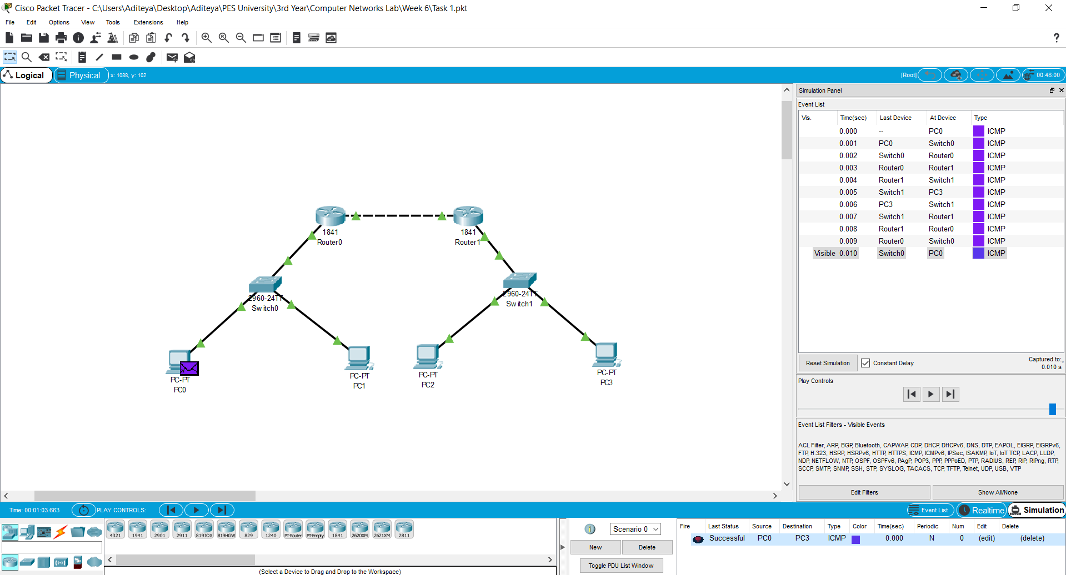

**1.2 Configuring Network and Routing Tables1.2.1 End Systems**

|  |  |  |  |  |
| --- | --- | --- | --- | --- |
| End System | Interface Name | IP Address | Subnet Mask | Gateway |
| PC0 | FastEthernet0 | 10.0.0.1 | 255.0.0.0 | 10.0.0.3 |
| PC1 | FastEthernet0 | 10.0.0.2 | 255.0.0.0 | 10.0.0.3 |
| PC2 | FastEthernet0 | 30.0.0.2 | 255.0.0.0 | 30.0.0.1 |
| PC3 | FastEthernet0 | 30.0.0.3 | 255.0.0.0 | 30.0.0.1 |

**1.2.2 Routers**

|  |  |  |  |
| --- | --- | --- | --- |
| Router | Interface Name | IP Address | Subnet Mask |
| Router0 | FastEthernet0/0 | 10.0.0.3 | 255.0.0.0 |
| Router0 | FastEthernet0/1 | 20.0.0.1 | 255.0.0.0 |
| Router1 | FastEthernet0/0 | 20.0.0.2 | 255.0.0.0 |
| Router1 | FastEthernet0/1 | 30.0.0.1 | 255.0.0.0 |

**1.2.3 Routing Table**

|  |  |  |
| --- | --- | --- |
| Router | Destination Network | Next Hop |
| Router0 | 30.0.0.0 | 20.0.0.2 |
| Router1 | 10.0.0.0 | 20.0.0.1 |

**2. Task 2**

The task performed above is repeated with another topology and the routing tables are configured appropriately.

**2.1 Configuring Topology**

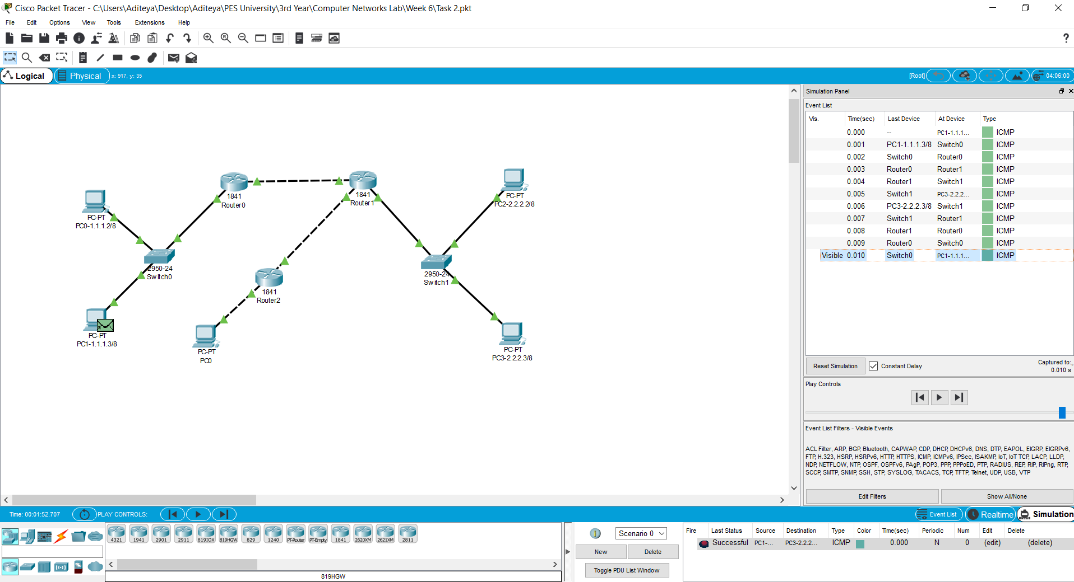

**2.2 Configuring Network and Routing Tables**

**2.2.1 End Systems**

|  |  |  |  |  |
| --- | --- | --- | --- | --- |
| End System | Interface Name | IP Address | Subnet Mask | Gateway |
| PC0-1.1.1.2/8 | FastEthernet0 | 1.1.1.2 | 255.0.0.0 | 1.1.1.1 |
| PC1-1.1.1.3/8 | FastEthernet0 | 1.1.1.3 | 255.0.0.0 | 1.1.1.1 |
| PC0 | FastEthernet0 | 6.6.6.2 | 255.0.0.0 | 6.6.6.1 |
| PC2-2.2.2.2/8 | FastEthernet0 | 2.2.2.2 | 255.0.0.0 | 2.2.2.1 |
| PC3-2.2.2.3/8 | FastEthernet0 | 2.2.2.3 | 255.0.0.0 | 2.2.2.1 |

**2.2.2 Routers**

|  |  |  |  |
| --- | --- | --- | --- |
| Router | Interface Name | IP Address | Subnet Mask |
| Router0 | FastEthernet0/0 | 1.1.1.1 | 255.0.0.0 |
| Router0 | FastEthernet0/1 | 3.3.3.1 | 255.0.0.0 |
| Router1 | FastEthernet0/0 | 3.3.3.2 | 255.0.0.0 |
| Router1 | FastEthernet0/1 | 5.5.5.2 | 255.0.0.0 |
| Router1 | Ethernet0/0/0 | 2.2.2.1 | 255.0.0.0 |
| Router2 | FastEthernet0/0 | 5.5.5.1 | 255.255.255.0 |
| Router2 | FastEthernet0/1 | 6.6.6.1 | 255.255.255.0 |

**2.2.3 Routing Table**

|  |  |  |
| --- | --- | --- |
| Router | Destination Network | Next Hop |
| Router0 | 2.2.2.0 | 3.3.3.2 |
| Router0 | 5.5.5.0 | 3.3.3.2 |
| Router0 | 6.6.6.0 | 3.3.3.2 |
| Router1 | 1.1.1.0 | 3.3.3.1 |
| Router1 | 6.6.6.0 | 5.5.5.1 |
| Router2 | 3.3.3.0 | 5.5.5.2 |
| Router2 | 1.1.1.0 | 5.5.5.2 |
| Router2 | 2.2.2.0 | 5.5.5.2 |